SF.SmokeTestScripts_TC_SF_OBRequiredFieldsOnSalesStage_Instance1_12-Apr-2017_04-44-06_PM_Invoke_Application.png



SF.SmokeTestScripts_TC_SF_OBRequiredFieldsOnSalesStage_Instance1_12-Apr-2017_04-44-15_PM_Login.png

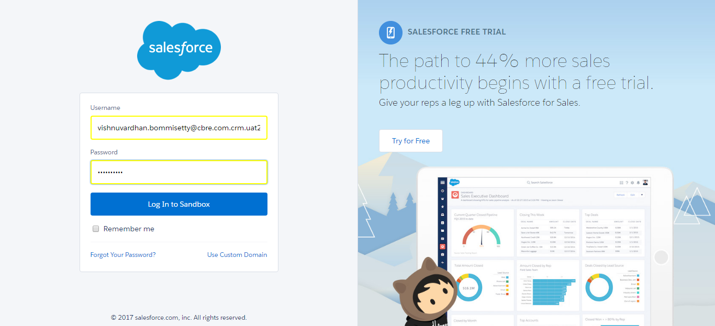

SF.SmokeTestScripts_TC_SF_OBRequiredFieldsOnSalesStage_Instance1_12-Apr-2017_04-44-28_PM_Verify_Login.png

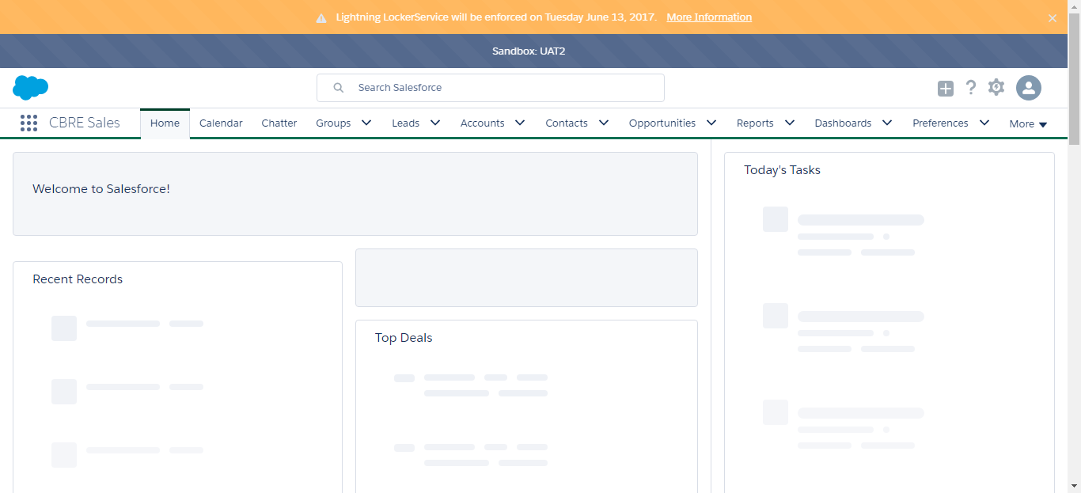

SF.SmokeTestScripts_TC_SF_OBRequiredFieldsOnSalesStage_Instance1_12-Apr-2017_04-44-30_PM_Verify_Fetch_Record.png

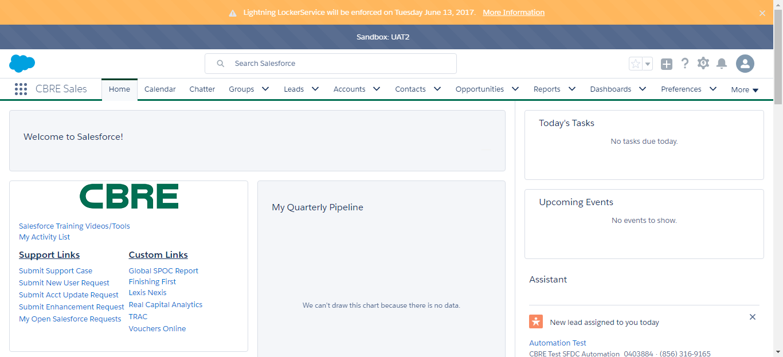

SF.SmokeTestScripts_TC_SF_OBRequiredFieldsOnSalesStage_Instance1_12-Apr-2017_04-44-45_PM_Verify_Opportunity_Required



SF.SmokeTestScripts_TC_SF_OBRequiredFieldsOnSalesStage_Instance1_12-Apr-2017_04-44-48_PM_Verify_Add_Opportunity_Page



SF.SmokeTestScripts_TC_SF_OBRequiredFieldsOnSalesStage_Instance1_12-Apr-2017_04-45-18_PM_Verify_Add_Opportunity_Page

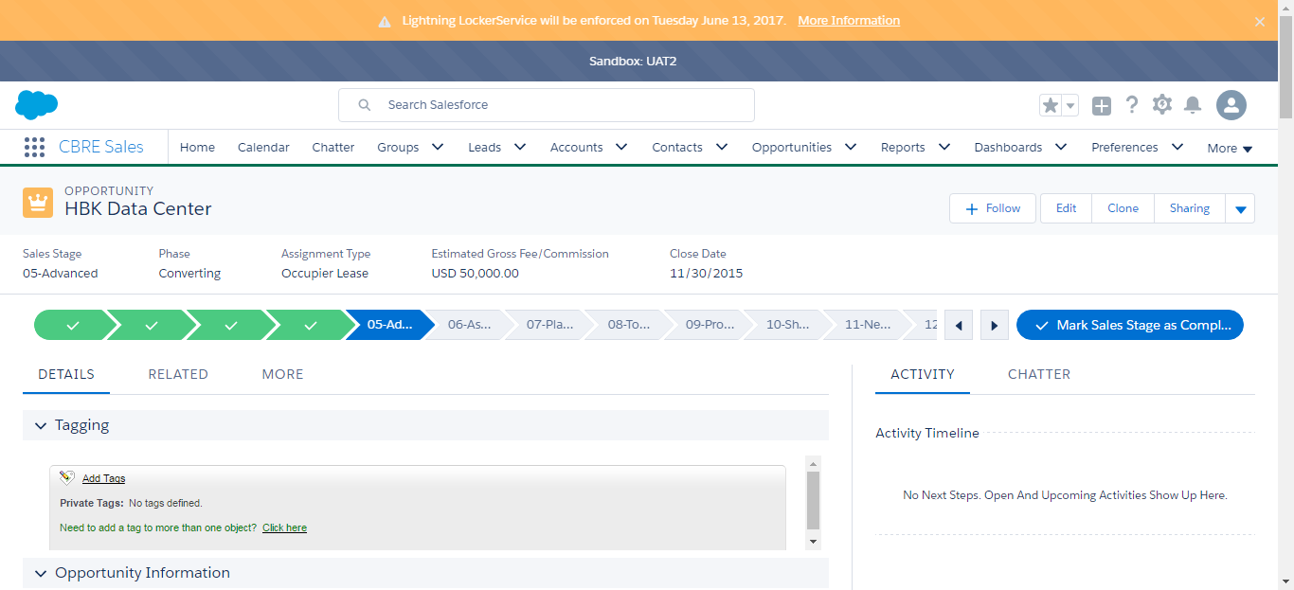

SF.SmokeTestScripts_TC_SF_OBRequiredFieldsOnSalesStage_Instance1_12-Apr-2017_04-55-26_PM_Error.png

